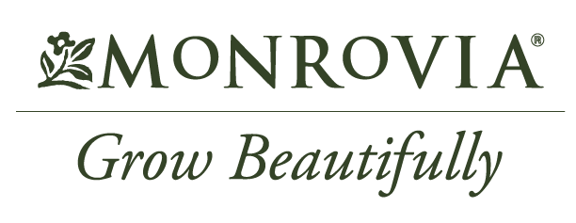

For Release: June 1, 2022
Bee a Winner with (GARDEN CENTER NAME’s) Pollinator Plant Giveaway
Celebrate the power of pollinators and attract birds, bees, and butterflies to your yard this season
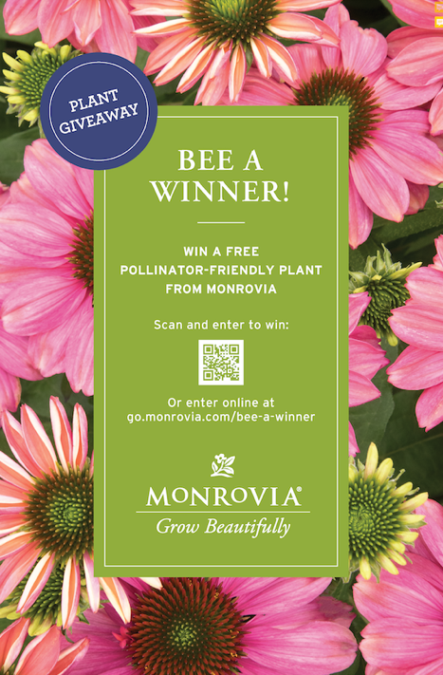
City, State – June is National Pollinators Month, and we’re celebrating at (Garden Center Name) by helping you create a pollinator-friendly environment, right in your own yard. From June 1st through June 16^{th,} we are partnering with Monrovia to offer the Bee a Winner giveaway. Visit our location and you could be a winner!

Simply scan the code from our Bee a Winner display or visit our website and click on the entry link. Ten lucky winners will receive a free Monrovia pollinator plant. Winners will be selected in a random drawing and invited to pick up their plant in our store.

“Almost every seed plant in the world needs to be pollinated. That’s why creating an environment that supports birds, bees, and other pollinators is so important,” says (NAME, TITLE at GARDEN CENTER NAME). “These pollinators are a crucial part of our ecosystem, essential to the food we eat and the gardens that we enjoy.

“One of our goals at Monrovia is to grow responsibly, working in harmony with nature, choosing plant varieties that add to the diversity in your garden,” says Katie Tamony, chief marketing officer at Monrovia. “Planting a wide variety of plants in your landscape not only adds beauty, it can help pollinators thrive by providing the food sources and habitat they need.”

Visit us at (NAME, LOCATION(s)) or enter online at (GARDEN CENTER LINK TO ENTRY FORM).

###
Need more information or want to talk with a local garden expert? For more information or to schedule an interview, contact: (NAME, EMAIL and PHONE)
About (GARDEN CENTER NAME)
Add a brief statement about your garden center. Be sure to include your location address and website.

About Monrovia
Inspired by the beauty of plants, gardens, and landscapes everywhere, Harry E. Rosedale, Sr. founded Monrovia in 1926 to be a premier grower of shrubs and trees. Monrovia collaborates with plant breeders around the world to introduce improved plant varieties to North America. Monrovia plants flourish once planted to beautify gardens and landscapes. Please visit Monrovia.com to learn more.

