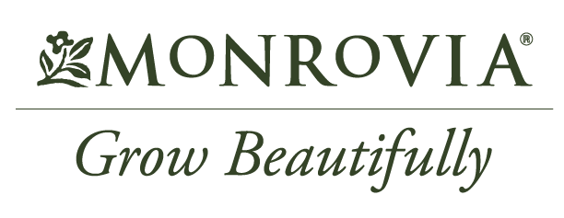

For Release: June 18, 2022
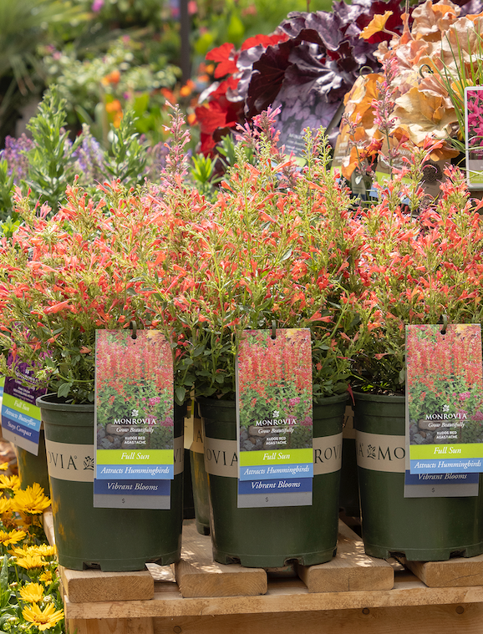
(GARDEN CENTER NAME’s) Announces Winners of Monrovia Pollinator Plant Giveaway
City, State – Both gardeners and pollinators are big winners at (Garden Center Name). The local retailer partnered with Monrovia to offer the Bee a Winner giveaway. Ten local customers are now taking home a free pollinator plant.

“June is Pollinator Month,” says (NAME, TITLE at GARDEN CENTER NAME). “We wanted to celebrate by increasing awareness of the importance of pollinators in our area and around the world. Birds, bees, and other pollinators are an essential part of the beautiful garden spaces we enjoy. They’re also needed to help grow the food we eat.” Adding pollinator-friendly plants that provide pollen, nectar and habitat can increase their activity in your area.
Image could be replaced with a picture of local winners. Be sure to include your logo in the background.

Learn more about adding pollinator-friendly plants to your landscape by visiting (Garden Center Name). Or head to Monrovia.com and search “pollinators” for a listing of pollinator-friendly plants and inspirational garden ideas.

###
Need more information or want to talk with a local garden expert? For more information or to schedule an interview, contact: (NAME, EMAIL and PHONE)
About (GARDEN CENTER NAME)
Add a brief statement about your garden center. Be sure to include your location address and website.

About Monrovia
Inspired by the beauty of plants, gardens, and landscapes everywhere, Harry E. Rosedale, Sr. founded Monrovia in 1926 to be a premier grower of shrubs and trees. Monrovia collaborates with plant breeders around the world to introduce improved plant varieties to North America. Monrovia plants flourish once planted to beautify gardens and landscapes. Please visit Monrovia.com to learn more.

